Experiment:3 Date:14/07/2026

Water Jug Problem Using Backtracking Algorithm

AIM:
To develop a Python program to solve the Water Jug Problem using the Backtracking Algorithm and obtain the required amount of water from two jugs.

Algorithm(Backtracking):
- Start with both jugs empty.
- Fill either jug.
- Pour water from one jug to the other.
- Empty a jug whenever required.
- Repeat the above steps until the target amount is obtained.
- Display each state of the jugs.
- Stop when the target is reached.

Program:
def water_jug(a, b, target):
x = y = 0
step = 0
print("\nInitial State")
print(x, y)
while x != target and y != target:
if x == 0:
x = a
elif y == b:
y = 0
else:
t = min(x, b - y)
x -= t
y += t
step += 1
print(f"\nStep {step}")
print(x, y)
print("\nTarget Reached")
a = int(input("Enter Capacity of Jug1 : "))
b = int(input("Enter Capacity of Jug2 : "))
target = int(input("Enter Target : "))
water_jug(a, b, target)

OUTPUT:
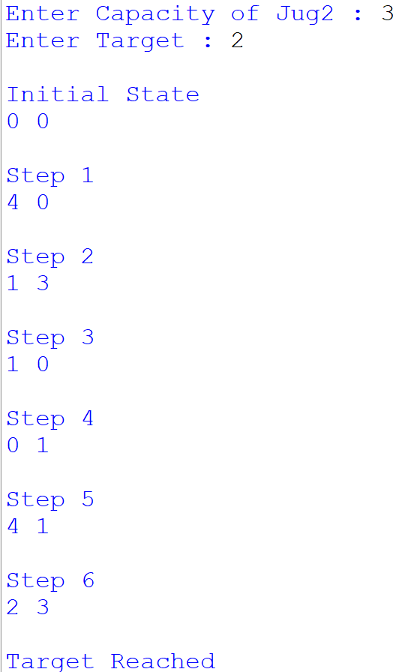

Result:
Thus, the Water Jug Problem was solved successfully using the Backtracking Algorithm, and the target amount of water was achieved.

